**NEWS CREDIBILITY USING DEEP LEARNING**

**PROJECT SYNOPSIS**

**OF B.E PROJECT**

**BACHELOR OF ENGINEERING**

**COMPUTER ENGINEERING**

**SUBMITTED BY**

AJINKYA SONWANE

GIRISH BHARAMBE

RAGINI BETRABET

CHETAN CHAUHAN

September 2019



**VISHWAKARMA INSTITUTE OF INFORMATION TECHNOLOGY, PUNE.**

**1. Motivation**

The issue of fake news has arisen recently as a potential threat to a high quality journalism and can also create many chaotic situations like mob lynching, etc. The source of this fake news most of the times has been various social networking sites like Twitter, Facebook, Whatsapp, etc.

Many big tech companies like Facebook, Twitter and Google are devising systems by which they can fight the wide spread of fake news. In addition, Governments across the globe are trying their best to avoid the same and hence there are many websites which have given an open challenge to fight fake news.

**2. Problem Statement**

To design a system that recognizes trending posts/articles on social media and assigns a ‘credibility score’ (score of truthfulness) to it.

**i.** **Assumptions** -

We will be comparing the trending posts with RSS Feeds of that related topic and the RSS Feeds will be assumed as valid source of news

**ii. Limitations** -

Only 10-15 valid sources will be considered based on how many ‘good’ score articles the source publishes.

**3. Scope**

To combat fake news spreading on social media platforms such as Twitter, facebook, Whatsapp. We aim to make the citizens aware of such news and hope to impact the society for a good cause.

**4. Methodology**

The methodology used by our system is the Stance Detection Model. Stance Detection is an important component of fake news detection. In this particular model,dataset of 75K pairs of claim and evidence is present having one to many relationship where our input will have a claim acting like a trending post from social media and evidence will act like RSS Feeds related to that particular post.

This particular dataset of 75K pairs have each pair of claim and evidence classified into either of the following **four** categories-

* Agrees
* Disagrees
* Discussed
* Unrelated

The dataset mentioned above is called [FakeNewsChallenge](http://www.fakenewschallenge.org/) Dataset will be fed to our neural network model for training.

**Data Flow Diagram** of how we intend to fight fake news -

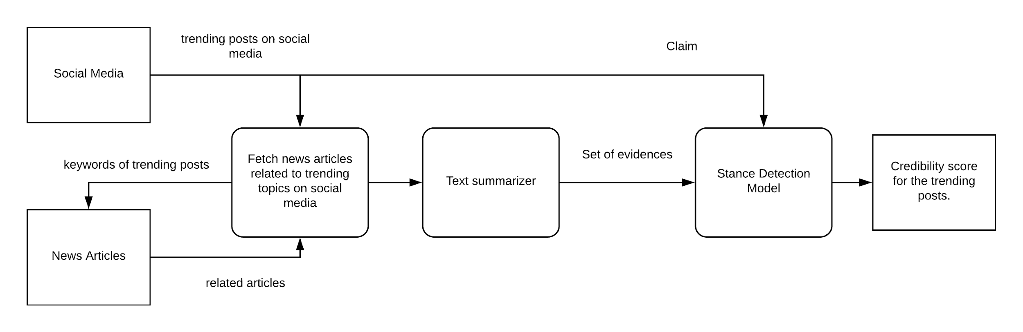

**5. (Expected) Analyses and Results**

The application system should tag the particular post with a credibility score or percentage based on its validity with different number of valid sources.

We expect to build an application which can credit the trending posts from social media.

**6. Conclusion**

With the rise of an alarming rate of fake news it will be beneficial to build a system which serves the purpose of making people aware of how valid a particular news may be. The system should hence be able to give percent of how valid the news using the stance detection model using deep learning.